Name: Jasmine McBride Semester: Spring 2017
ESSENTIAL CONDITION ONE: Effective Instructional Uses of Technology Embedded in Standards-Based,
Student-Centered Learning

ISTE Definition: Use of information and communication technology (ICT) to facilitate engaging approaches to learning.
Guiding Questions:
- How is technology being used in our school? How frequently is it being used? By whom? For what purposes?
- To what extent is student technology use targeted toward student achievement of the Georgia Learning Standards (GPSs, CCSs)?
- To what extent is student technology use aligned to research-based, best practices that are most likely to support student engagement, deep understanding of content, and transfer of knowledge? Is day-to-day instruction aligned to research-based best practices?
Strengths | Weaknesses | Opportunities | Threats
- The majority of the teachers (60%) at Russell are constantly using technology in everyday instruction  - Russell teachers use classroom desktops, classroom laptops, teachers use their personal laptops, teachers check out iPad carts, and teachers take their students to the computer lab  - Teachers at Russell use technology to give instruction, give students additional practice, to assess students and as center  - 65.71% of teachers at Russell believe that incorporating technology in everyday instruction effects student achievement | - Some of the technology at Russell needs to be updated  - Some teachers feel that there is not enough technology at Russell  - There is a lack of student led activities when using technology | - Technology is an additional resource for teachers to use with students  - Technology engages students  - Technology is an efficient way for teachers to assess without having to grade work  - Title 1 grants | - Technology can break or have malfunctions  - Some of Russell’s staff is not comfortable enough with technology to use it to it’s best ability  - Some teachers don’t know if technology is beneficial to student success, therefore they are not as willing to use it consistently
Summary of Results/Conclusions:
The majority of the staff at Russell is using technology consistently or sees that using technology is beneficial. Russell has many opportunities for technology use. Technology use at Russell can benefit from updated equipment and from having more technology options to choose from.

Recommendations from Gap Analysis: I recommend that Russell look into ways to invest into updating its current technology and then look into ways to purchase additional technology for each classroom. I suggest that administration start pushing for technology in everyday instruction and have some kind of speaker or professional development that explains and shows the benefits of using technology in instruction. Teachers should give students the opportunity to use technology in their own ways when doing activities and have student led activities.

Data Sources: School Strategic Plan, Needs Assessment Survey,

ESSENTIAL CONDITION TWO: Shared Vision

ISTE Definition: Proactive leadership in developing a shared vision for educational technology among school personnel, students, parents, and the community.
Guiding Questions:
- Is there an official vision for technology use in the district/school? Is it aligned to research-best practices? Is it aligned to state and national visions? Are teachers, administrators, parents, students, and other community members aware of the vision?
- To what extent do teachers, administrators, parents, students, and other community members have a vision for how technology can be used to enhance student learning? What do they believe about technology and what types of technology uses we should encourage in the future? Are their visions similar or different? To what extent are their beliefs about these ideal, preferred technology uses in the future aligned to research and best practice?
- To what extent do educators view technology as critical for improving student achievement of the GPS/CCSs? To preparing tomorrow’s workforce? For motivating digital-age learners?
- What strategies have been deployed to date to create a research-based shared vision?
- What needs to be done to achieve broad-scale adoption of a research-based vision for technology use that is likely to lead to improved student achievement?
Strengths | Weaknesses | Opportunities | Threats
- Communication from school to home  - The county (Cobb) is doing CTLS touchstone assessments, which require students to use iRespond  - There are staff members at Russell who want to be trained/ professionally developed in technology resources  - Administration is pushing for more technology use with One Drive and One Note  - Each classroom has desktops and laptops for student use | - Lack of communication about technology from school to home  - Russell does not currently have a vision for technology  - Russell shares a technology specialist with other schools so professional development time and constant ready assistant is not available  - There is not a lot of training/ professional developments at Russell for teachers to get acquainted with new technology  - Besides CTLS technology is not mentioned in the schools strategic plan  - Some students have a hard time properly using technology especially the iRespond remotes in primary grades | - The great parent to school relationships that Russell has makes it easy to interest parents in learning about and implementing technology  - iRespond testing is a great way for teachers and administration to collect a variety of data at one time  - Use of One Drive and One Note gives staff easy access to all documents instead of looking  - With having a technology specialist and the expectation of technology increasing, technology use will increase in the building  - Teachers have the opportunity to incorporate technology into instruction and practice because each class has some desktops and two laptops | - Through this 2016-2017 school year we have had some difficulties with the touchstone test (remotes not logging kids in, remotes logging students off during the test, answers being keyed in wrong causing students not to get the correct score)  - The staff will be loosing our part time technology specialist, which mean it will be more difficult to be trained and assisted with new technology  - Improper use of technology tools can cause inaccurate data
Summary of Results/Conclusions:
When it comes to technology Russell has the ability to incorporate technology daily. Russell has the opportunity to make technology a major part of its strategic plan. Many teachers at Russell use technology on a daily basis and want to see the use of technology at Russell grow. Russell has an amazing parent to school relationship which opens up the opportunity to get parents on board and interested in technology implementation.

Recommendations from Gap Analysis: I suggest that Russell do more training with teachers and students on using iRespond before using iRespond results for data. I would suggest that teachers use the technology tools that they are testing with for regular instruction as well so that students have more chances to become familiar with the devices.

Data Sources: School Strategic Plan, Needs Assessment Survey

ESSENTIAL CONDITION THREE: Planning for Technology

ISTE Definition: A systematic plan aligned with a shared vision for school effectiveness and student learning through the infusion of ICT and digital learning resources.
Guiding Questions:
- Is there an adequate plan to guide technology use in your school? (either at the district or school level? Integrated into SIP?)
- What should be done to strengthen planning?
- In what ways does your school address the needs of diverse populations in the school or district to include how race, gender, socio-economic, and geographic diversity giving consideration to how these factors commonly affect K-12 students’ access to school and beyond-school access to high-speed Internet, modern computing devices, software, knowledgeable technology mentors, culturally-relevant digital content, and other affordances critical to technology literacy acquisition.
Strengths | Weaknesses | Opportunities | Threats
- Russell is leaning towards the use of One Note to complete lessons, meeting minute notes, and important documents  - Russell teachers share and store documents in One Drive  - Russell has computers in the parent resources room for parents to come in and use if needed | - There is limited training being done on how to use One Note to complete the task that will be required through the source next school year  - The same few parents take advantage of the technology resources the school offers | - All important information will be in a central location at Russell where all teachers can easily gain access  - Having the majority of Russell’s important documents in a central location will save teachers time and confusion from having to constantly search for documents and information | - Limited training on next years required technology can cause a lot of trial am error situations next school year
Summary of Results/Conclusions:
Although Russell does not really include technology in its strategic plan, Russell is taking steps to incorporate more technology. Russell is using technology to help make the school community run more efficiently. The entire Russell staff will have to use One Note this upcoming school year to access and submit the majority of their important documents. Russell does provide technology resources for parents who need it.

Recommendations from Gap Analysis: I suggest that Russell have multiple staff or grade level trainings on the technology that will be required for the next school year to eliminate confusion and misuse next school year. Teachers should have opportunity to practice using the required technology with the technology specialist and administrations so that teachers are aware of expectations. I would advertise to parents that there are technology resources for them in the school building and offer opportunities for parents to learn more about the technology being used.

Data Sources: School Strategic Plan, Needs Assessment Survey

ESSENTIAL CONDITION FOUR: Equitable Access (Specifically Low SES and gender groups)

ISTE Definition: Robust and reliable access to current and emerging technologies and digital resources.
Guiding Questions:
- To what extent do students, teachers, administrators, and parents have access to computers and digital resources necessary to support engaging, standards-based, student-centered learning?
- To what extent is technology arrange/distributed to maximize access for engaging, standards-based, student-centered learning?
- What tools are needed and why?
- To what extent are strategies needed to address equity issues among Low SES and gender groups? What are examples of strategies that would benefit your school/district? (required)
- Do students/parents/community need/have beyond school access to support the shared vision for learning?
Strengths | Weaknesses | Opportunities | Threats
- Each classroom at Russell has four desktop computers, two laptops, and a Promethean Board  - Each Teacher and Paraprofessional has his/her own laptop  - Teachers have the opportunity to check out laptop carts from the library  - There are two computer labs in the building | - A lot of the devices at Russell needed to be updated (some laptops take 10 to 15 minutes to load after logging in and some desktops need to be replaced)  - Computer lab locations are not ideal for all grade levels at Russell  - Russell has limited iPads to be checked out which means teachers rarely can use laptops due to having to share | - Having technology in every classroom gives students the opportunity to use technology throughout the day  - Teachers are able to use Web 2.0 tools in the classroom due to having access to technology inside each classroom | - Without proper training and professional development on technology, technology can be wasted which means the school will not purchase more  - Money and other school needs could limit more technology devices coming into the building
Summary of Results/Conclusions: Students staff and parents at Russell have access to devices. Each classroom at Russell has technology devices which means technology can be used daily in the classroom. Although there us technology in every room, it would be ideal to have access to more technology so that its use can increase. Technology devices not being updated or up to date limit the amount that the device can be used.

Recommendations from Gap Analysis:
I would suggest finding more ways to equally give teachers the opportunity to use the additional technology resources in the building. I would suggest the school looking into ways to no just update technology but also place more technology devices in classrooms so ore students can use technology at a time.

Data Sources:

ESSENTIAL CONDITION FIVE: Skilled Personnel

ISTE Definition: Educators and support staff skilled in the use of ICT appropriate for their job responsibilities.
Guiding Questions:
- To what extent are educators and support staff skilled in the use of technology appropriate for their job responsibilities?
- What do they currently know and are able to do?
- What are knowledge and skills do they need to acquire?

(Note: No need to discuss professional learning here. Discuss knowledge and skills. This is your needs assessment for professional learning. The essential conditions focus on “personnel,” which includes administrators, staff, technology specialists, and teachers. However, in this limited project, you may be wise to focus primarily or even solely on teachers; although you may choose to address the proficiency of other educators/staff IF the need is critical. You must include an assessment of teacher proficiencies.)
Strengths | Weaknesses | Opportunities | Threats
- The majority of the staff feel very comfortable or feels that they have technology mastered when asked  - Many staff members are interested in receiving training/ professional development on technology and resources  - The majority of the staff uses technology daily in their classroom for instruction | - Lack of training/ professional development on technology in the building  - Teachers at Russell are not all using technology to its fullest potential when incorporating technology in instruction | - District offers professional learning on basic skills and software as well as instruction on best practices for integration  - Availability of free, online, tutorials and training modules | - Without constant training teachers will have a difficult time keeping up with what’s new and most effective at the time
Summary of Results/Conclusions:
Russell’s staff is very skilled in technology and willing to improve and learn more. Russell is in need of more trainings/ professional development to increase the staffs’ knowledge and ability. Russell staff uses technology daily and the majority of the staff uses technology daily in their classroom instruction. Although the district offers numerous trainings, many of Russell’s staff don’t participate due to it not being delivered in a way that they would prefer.

Recommendations from Gap Analysis: I would recommend Russell have more opportunities for training/ professional development. I would suggest finding out exactly what the staff needs and wants and basing training off of that.

Data Sources: School Strategic Plan, Needs Assessment Survey

ESSENTIAL CONDITION SIX: Ongoing Professional Learning

ISTE Definition: Technology-related professional learning plans and opportunities with dedicated time to practice and share ideas.
Guiding Questions:
- What professional learning opportunities are available to educators? Are they well-attended? Why or why not?
- Are the current professional learning opportunities matched to the knowledge and skills educators need to acquire? (see Skilled Personnel)
- Do professional learning opportunities reflect the national standards for professional learning (NSDC/Learning Forward)?
- Do educators have both formal and informal opportunities to learn?
- Is technology-related professional learning integrated into all professional learning opportunities or isolated as a separate topic?
- How must professional learning improve/change in order to achieve the shared vision?
Strengths | Weaknesses | Opportunities | Threats
- Russell staff has ideas on what they would like to be trained on (useful apps, programs for daily instruction, coding, research, smart boards, and how to implement technology into instruction)  - Russell’s staff knows how they want to be trained to best receive the information ( break out groups, in person, small group training) | - Trainings/ professional developments that are held do not have a lot of attendance  - Many trainings offered are online instead of in person and/or not at Russell  - Besides the CTLS trainings for assessing students, there are not trainings on how to incorporate technology in the classroom  - There’s not many informal way of learning about technology offered | - Title 1 funding provides opportunities for professional development | - Lack of training and /or lack of being willing to go to the types of trainings that are offered cause a result of no growth
Summary of Results/Conclusions:
The staff at Russell wants to learn more about technology and be trained, but they have preferences on how they want to be trained. The trainings that are currently offered to the staff are not well attended, but the some staff members are willing to be trained if it’s the way they prefer.

Recommendations from Gap Analysis:
I would recommend that Russell offer different trainings different ways to meet the learning wants of the staff. I would also suggest training the staff in what they want so that they will buy into the training.

Data Sources: School Strategic Plan, Needs Assessment Survey

ESSENTIAL CONDITION SEVEN: Technical Support

ISTE Definition: Consistent and reliable assistance for maintaining, renewing, and using ICT and digital resources.
Guiding Questions:
- To what extent is available equipment operable and reliable for instruction?
- Is there tech assistance available for technical issues when they arise? How responsive is tech support? Are current “down time” averages acceptable?
- Is tech support knowledgeable? What training might they need?
- In addition to break/fix issues, are support staff available to help with instructional issues when teachers try to use technology in the classroom?
Strengths | Weaknesses | Opportunities | Threats
- Russell has a technology specialist who comes twice a week to assist with training and technology needs  - The school’s technology specialist is very knowledgeable and anything she is unaware of she finds the answer  - There is also a tech support guy in the building throughout the week to help with technology issues | - The schools technology specialist is shared with other schools so she is not assessable in person every day  - Since the technology specialist is only at the school twice a week she is not always there to help with technology issues in instruction, but the technology support employee is available to come and help with issues through the day just not instruction | - Having the technology specialist gives Russell the opportunity to receive training and personal assistance during the school day  - Having two employees who specialize in technology gives the school’s employees many chances to be trained and assisted with technology | - The technology specialist is only with Russell for a year
Summary of Results/Conclusions:
Russell has opportunity for a lot of one on one and group assistance and training with technology. This school year is a good time for Russell’s staff to get familiar and comfortable with technology while they have two types of support. Next school year Russell will only have technology support but not a specialist to help with incorporating with instruction.

Recommendations from Gap Analysis: I would recommend Russell looking into a full time technology specialist/ coach. If Russell is going to incorporate more technology it would be a great idea to have onsite support for a couple years.

Data Sources: School Strategic Plan, Needs Assessment Survey

ESSENTIAL CONDITION EIGHT: Curriculum Framework

ISTE Definition: Content standards and related digital curriculum resources.
Guiding Questions:
- To what extent are educators, students, and parents aware of student technology standards? (ISTE Standards for Students)
- Are technology standards aligned to content standards to help teachers integrate technology skills into day-to-day instruction and not teach technology as a separate subject?
- To what extent are there digital curriculum resources available to teachers so that they can integrate technology into the GPS/CCS as appropriate?
- How is student technology literacy assessed?
Strengths | Weaknesses | Opportunities | Threats
- There are a couple teachers in the building who have a degree in instructional technology, so they are aware of the standards | - The majority of the teachers, all parents and all the students are not aware of the technology standards  - Teachers are not aware of all the digital curriculum resources that are offered | - Teachers have the opportunity to find ways to teach and assess student technology literacy and skill with the assistance of the technology specialist | - Teachers and students will be less and less able to use digital resources safely and ethically if they are not properly taught
Summary of Results/Conclusions:
Russell does not have a focus on technology standards, therefore teachers do not know if technology standards and content standards go hand in hand. Digital curriculum resources are available, but many teachers are unaware of how to access most of them. Students do not have technology literacy and are not taught technology standards. Parents are not given technology standards and technology standards are not a concern for the teachers at Russell.

Recommendations from Gap Analysis:
I recommend having a specials rotation where the kids learn about technology and technology standards during the week. I would suggest sending home information about technology standards and expectations to parents. The staff should be trained or taught about the technology standards and expectations.

Data Sources: School Strategic Plan, Needs Assessment Survey

References

http://www.cobbk12.org/russell/

http://www.cobbk12.org/russell/2016-17_RussellStrategicPlan.pdf

Appendices

Appendix A:
1. How would you rate you technology abilities?
2. How comfortable do you feel with assisting others with technology?
3. How often do you use technology in your everyday instruction?
4. How comfortable are you with using technology in your everyday instruction?
5. Do you feel that technology in everyday instruction effects students achievement?
6. How often do you use technology in your classroom?
a. less than twice a week
b. 2-3 times a week
c. 4-5 times a week
d. in mostly every lesson/ activity
7.What kind of technology are you interested in learning more about?
8. What improvements would you like to see Russell make in regards to technology?
9. What kind of professional developments would you like to see to help with technology at Russell?
10. How would you like to be professionally developed/ trained on technology?

Appendix B:

While completing the SWOT analysis, I used a survey to get a better idea. I sent the survey out to the entire Russell staff and thirty-five teachers participated anonymously. Based on the staff members who participated in the survey I feel that technology has a bright future at Russell. The majority of Russell’s teachers use some type of technology daily. The majority of the staff felt that it is important to incorporate technology in everyday instruction. Most teachers also feel comfortable with the technology that they are using and a few stated that they would like to have professional developments on new technology and technology that could be incorporated into their daily instruction. In the comments there were quite a few teachers who expressed that Russell needed newer technology and more laptops and iPads per grade level/ in each classroom. Below are some of the results from the questions that did not require a written response.

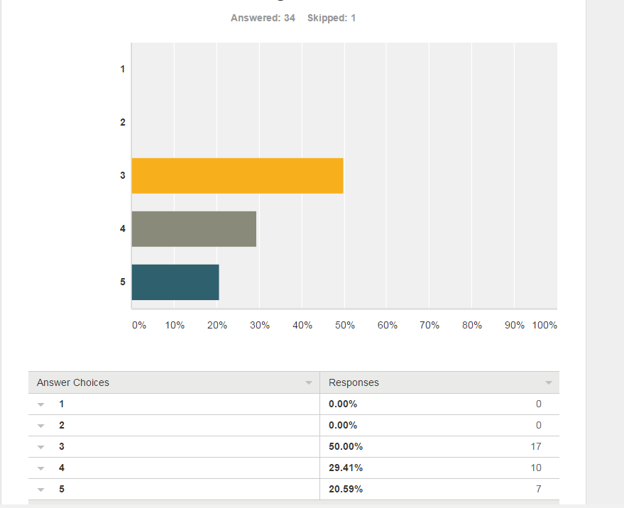

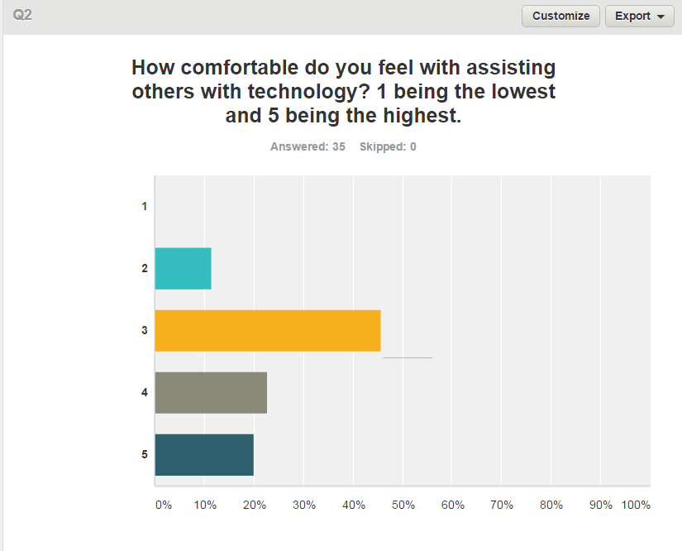
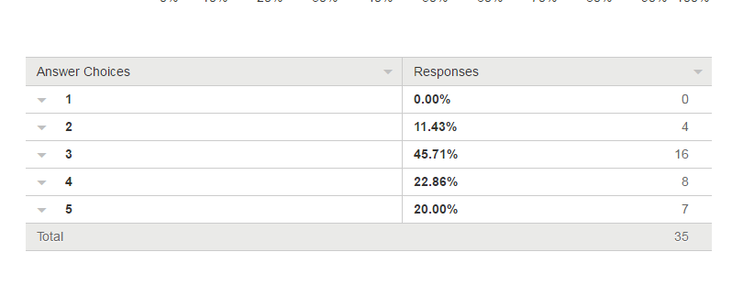
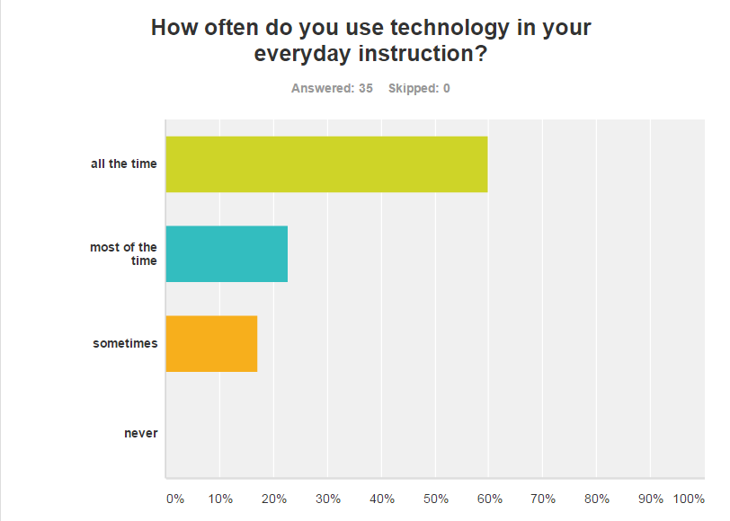
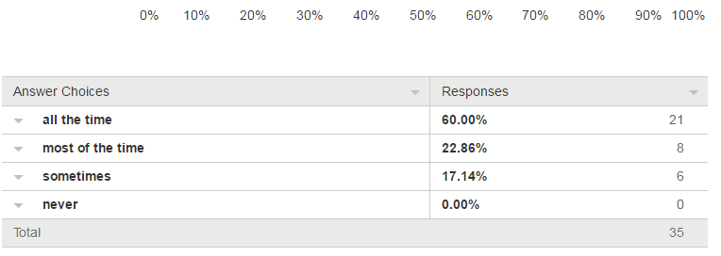
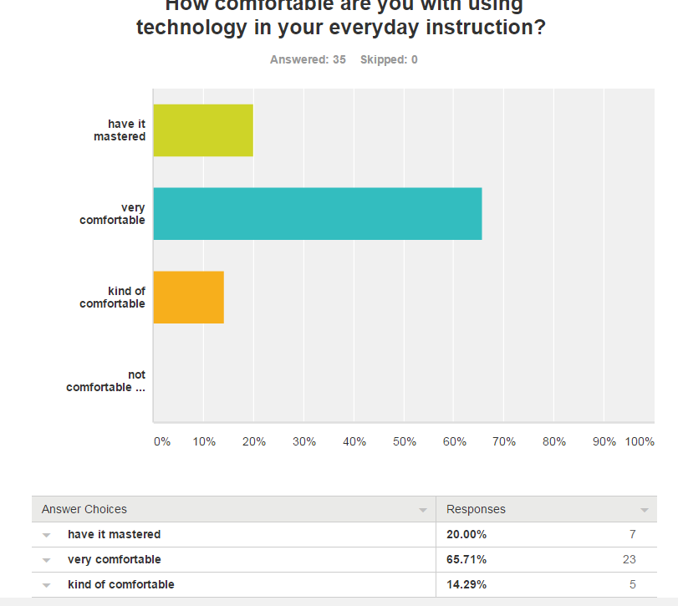

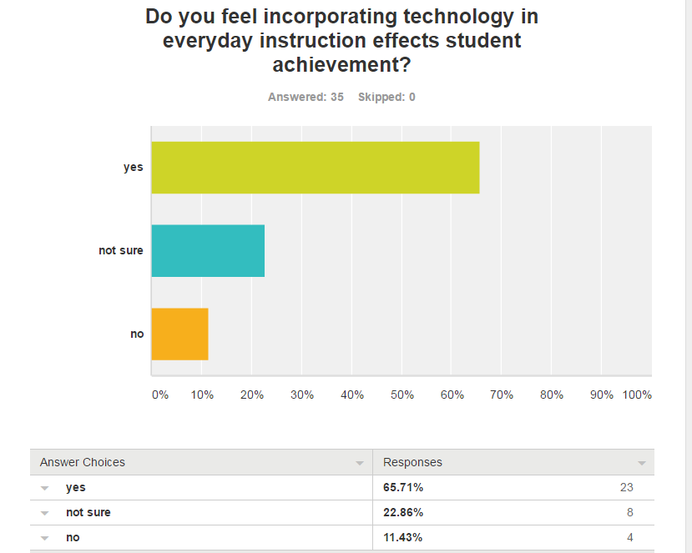

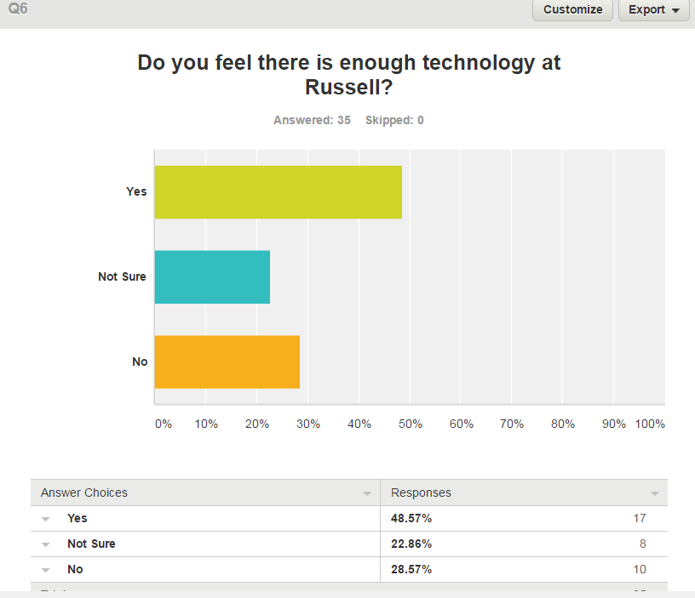

Completing the SWOT analysis was a meaningful task and was a great learning experience. This experience taught me how to analyze my schools needs in reference to technology. It helped me learn more about the needs and wants of my staff members when it comes to technology as well. I was able to see the strengths and weaknesses of my schools staff members and of the way technology is used in the school. This analysis helped me determine the direction technology is going at Russell and the direction that Russell has the potential to go with technology. Before sharing this information with others or making decisions, I would make sure I had feedback from more staff members and I would make sure I had feedback from administration and our current part time technology specialist.

